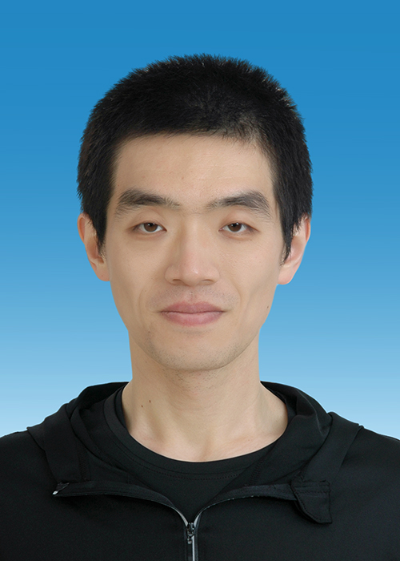

**Other Papers**

[1] Zhang, Y., **Feng, K.,** Song, D., Wang, Q., Ye, S., Liu, J., & Kainz, M. J. (2023). Dietary fatty acid transfer in pelagic food webs across trophic and climatic differences of Chinese lakes. *Science of The Total Environment*, 169562.

[2] Huang, G., Wang, Q., Du, X., **Feng, K.**, Ye, S., Yuan, J., Liu, J., Li, Z., & De Silva, S. S. (2020). Modeling trophic interactions and impacts of introduced icefish (*Neosalanx taihuensis* Chen) in three large reservoirs in the Yangtze River basin, China. *Hydrobiologia*, 847(17), 3637-3657.

[3] Wang, Q., **Feng, K.**, Du, X., Yuan, J., Liu, J., & Li, Z. (2022). Effects of land use and environmental gradients on the taxonomic and functional diversity of rotifer assemblages in lakes along the Yangtze River, China. *Ecological Indicators*, 142, 109199.

[4] Xiong, X., Xie, S., **Feng, K.**, & Wang, Q. (2022). Occurrence of microplastics in a pond-river-lake connection water system: How does the aquaculture process affect microplastics in natural water bodies. *Journal of Cleaner Production*, 352, 131632.

[5] Wang, Z., Wang, Q., Wang, J., Wei, H., Qian, J., Zhang, Y., **Feng, K.**, Chen, Q., Yuan, J., Liu, J., & Li, D. (2022). Evaluation of the control effect of bighead carp and silver carp on cyanobacterial blooms based on the analysis of differences in algal digestion processes. *Journal of Cleaner Production*, 375, 134106.

[6] Qian, J., Xiao, L., **Feng, K.**, Li, W., Liao, C., Zhang, T., & Liu, J. (2022). Effect of dietary protein levels on the growth, enzyme activity, and immunological status of *Culter mongolicus* fingerlings. *Plos one*, 17(2), e0263507.

I have strong interests in fish biology and community ecology. The experience of earning a bachelor degree in biological sciences gave me a comprehensive understanding of biology from micro to macro levels. I obtained my dual PhD degree through a total of 6 years of experience as a PhD candidate in China and France. During this period, my research topic was mainly based on using functional trait methods to study the response to multi-dimensional diversity of fish communities and community assembly mechanisms under multiple environmental stresses in the lakes of middle reach of Yangtze River basin. I am particularly interested in the protection and restoration of freshwater ecosystems and fish communities. I am proficient in ecological statistical principles and models. I can skilfully use ecological tools such as R, MATLAB, and Arcgis, etc.

Self introduction

**EDUCATION**

Phd

September 2017 - June 2023

Bachelor degree

September 2013 - June 2017

University of Chinese Academy of Sciences

Institute: Institute of Hydrobiology Chinese Academy of Sciences

Specialty: Aquatic biology

Straight-to-PhD Student

China Agricultural University

College: College of Biological Science

Specialty: Biological Science

University Toulouse III Paul Sabatier

Lab: Laboratoire Évolution & Diversité Biologique (EDB), UMR 5174

Specialty: Ecologie, biodiversité et évolution

Supervisor: Dr. Bernard HUGUENY; Prof. Sovan LEK.

Joint-Phd

February 2022 - February 2023

1. Functional structure and diversity of freshwater fish communities based on functional traits.

2. Response assembly mechanism of fish community under multiple environmental stresses

3. Protection and restoration of freshwater fish communities and lake ecosystem.

research interests

Name: Kai FENG

Birthday: 21/10/1994

Tel: **+36 301789714**

E-mail: **feng.kai@blki.hu;**

**fengkai3609@gmail.com**

INFORMATION

PaPer

**First Authored Papers**

[1] **Feng, K.**, Deng, W., Zhang, Y., Tao, K., Yuan, J., Liu, J., Li, Z., Lek, S., Wang, Q., & Hugueny, B. (2023). Eutrophication induces functional homogenization and traits filtering in Chinese lacustrine fish communities. *Science of The Total Environment*, 857, 159651. https://doi.org/10.1016/j.scitotenv.2022.159651

[2] **Feng, K**., Deng, W., Li, H., Guo, Q., Tao, K., Yuan, J., Liu, J., Li, Z., Lek, S., Hugueny, B & Wang, Q. (2023). Direct and indirect effects of a fishing ban on lacustrine fish community do not result in a full recovery. *Journal of Applied Ecology*. (In press) https://doi.org/10.1111/1365-2664.14491

[3] **Feng, K.**, Yuan, J., Zhang, Y., Qian, J., Liu, J., Li, Z., Lek, S., & Wang, Q. Application of artificial spawning substrates to support lacustrine fish recruitment and fisheries enhancement in a Chinese lake. *Frontiers in Ecology and Evolution*, 10, 1062612. https://doi.org/10.3389/fevo.2022.1062612